## Reports/ Audit / Rx Modification Log:

Request:

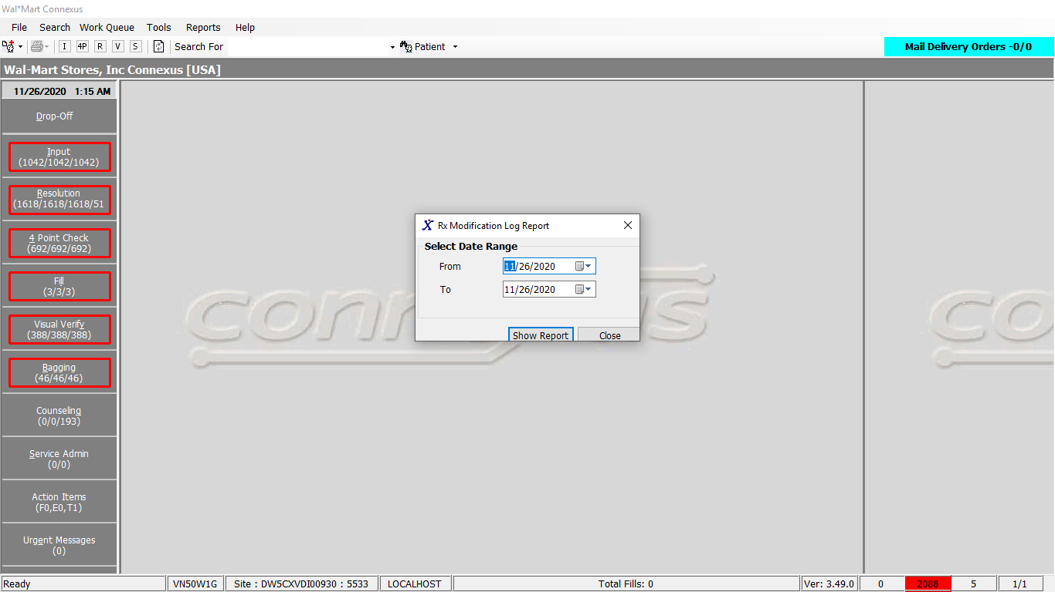

Response:

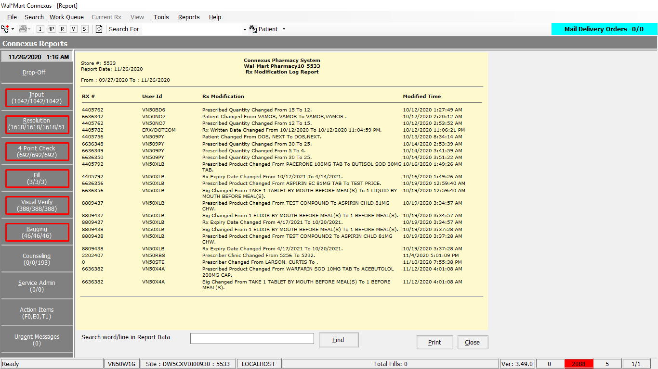

Query:

Public Const GetRxModificationInfo As String = " SELECT rx.rx_nbr,aa.userid,aa.activity_ts,aa.activity_comment " &

" FROM error_and_audit:appl_activity aa, rx21c:rx rx " &

" WHERE rx.rx_id = aa.activity_value" &

" AND DATE(activity_ts) BETWEEN ? AND ?" &

" AND activity_type_code IN (?,?)" &

" ORDER BY activity_ts"

DAL:

Public Function GetRxModificationData(ByVal siteId As Integer, ByVal startDate As Date, ByVal endDate As Date) _

As List(Of GetRxModificationInfoBE) Implements IReportDAL.GetRxModificationData

Using (New Tracer(ConnexusCommonConstants.ConnexusTracer))

Dim info As List(Of GetRxModificationInfoBE) = Nothing

Dim parameterlist As New List(Of DbParameter)

Dim AuditSerializer As Xml.Serialization.XmlSerializer = CacheWrapperDal.AuditSerializer

Dim auditInfo As List(Of Audit.AuditEntry) = Nothing

Dim reader As IO.TextReader = Nothing

parameterlist.Add(ParameterHelper.BuildParameter("StartDate", DbType.Date, startDate))

parameterlist.Add(ParameterHelper.BuildParameter("EndDate", DbType.Date, endDate))

parameterlist.Add(ParameterHelper.BuildParameter("ActivityTypeCode", DbType.Int32, Audit.AuditActivityType.RxModificationLog))

'DEA Audit reporting changes - start

parameterlist.Add(ParameterHelper.BuildParameter("ActivityTypeCodeNonstoreAssociate", DbType.Int32, Audit.AuditActivityType.RxModifyNonStoreAssociate))

'DEA Audit reporting changes - end

Using dr As IDataReader = ExecuteReader(DatabaseEnum.Error_And_Audit, siteId, ReportQueries.GetRxModificationInfo, parameterlist)

While dr.Read

Dim item As New GetRxModificationInfoBE

If Not dr.IsDBNull(dr.GetOrdinal("rx_nbr")) Then

item.RxNbr = dr.GetInt32(dr.GetOrdinal("rx_nbr"))

End If

If Not dr.IsDBNull(dr.GetOrdinal("userid")) Then

item.UserId = dr.GetString(dr.GetOrdinal("userid"))

End If

If Not dr.IsDBNull(dr.GetOrdinal("activity_ts")) Then

item.LastChangeTs = dr.GetDateTime(dr.GetOrdinal("activity_ts"))

End If

If Not dr.IsDBNull(dr.GetOrdinal("activity_comment")) Then

reader = New IO.StringReader(dr.GetString(dr.GetOrdinal("activity_comment")))

auditInfo = CType(AuditSerializer.Deserialize(reader), List(Of Audit.AuditEntry))

Dim commentInfo As Audit.AuditEntry = auditInfo.Find(Function(data As Audit.AuditEntry) _

data.Name.Equals(ServicesCommonConstants.Comment,

StringComparison.InvariantCultureIgnoreCase))

item.ModificationDetails = commentInfo.Value

End If

If info Is Nothing Then

info = New List(Of GetRxModificationInfoBE)

End If

info.Add(item)

End While

End Using

Return info

End Using

End Function